Cloud platform is essential for your future study because you cannot train large models on your local machines. In this module, we provide Microsoft Cloud Platform Devbox Virtual Machine for you. This is a good start for you to learn cloud computing and virtual machines.

Anaconda and Jupyter Notebook are pre-installed in the virtual machines and you don’t need to install it anymore. You can also use google.

Please follow the rules below to use the virtual machine:

* We will monitor all the traces on your machine. Please don’t visit illegal websites and break the law.

你的所有行动都会被记录，请不要访问违法违规网站。

* Don’t use VMs on Wednesday and Thursday except your lab sessions.

**每周三周四内**除了自己的lab session外的其他时间请不要登陆，会影响别的同学使用。

* Your classmates will SHARE the virtual machine with you (at most 3 students will share one virtual machine). You can find the email address of your VM shared users in the receiver list of this email. **Please collaborate to make everyone happy**. If something wrong happens among your team, please report to [Siqi.Huang@xjtlu.edu.cn](mailto:Siqi.Huang@xjtlu.edu.cn)

最多三位同学会共享一台虚拟机(虚拟机很贵，且用且珍惜)。你可以在这封邮件收件人列表里发现和你共享虚拟机的同学邮箱地址，请共同合作，合理安排使用虚拟机。如果合作出现重大问题，请联系 [Siqi.Huang@xjtlu.edu.cn](mailto:Siqi.Huang@xjtlu.edu.cn)

* Please remember to save your work and backup it on your box using browser.

请记得保存你的工作并且利用浏览器上传到box等云平台，防止虚拟机被误删等意外情况发生。

* Don’t store your personal data on the virtual machine.

请不要在虚拟机上保存私人文件 (包括你的coursework)，建议每次关闭虚拟机时备份好作业后删除本地文件。如果觉得麻烦，可以使用加密文件夹，one drive， Github等进行项目管理。

* Please shut down the virtual machine after you disconnect it.

请在断开链接后关闭虚拟机，参考后面的具体教程。否则会一直占用资源并且学院需要为此付费。

* The virtual machine will open during work hours in our lecture, please feel free to use it.

虚拟机在教学期间的工作时间（包含周末）持续为大家开放，欢迎大家按需使用。

* More information about Devbox VM will be shared in the AI and Python workshop

Please open the following link in your browser (请在你的本地浏览器里打开链接):

<https://devportal.microsoft.com/>

Use the account and password attached in the email to login:

For example: [DevBox.Student800@XJTLUMS.onmicrosoft.com](mailto:DevBox.Student800@XJTLUMS.onmicrosoft.com) password: 123456

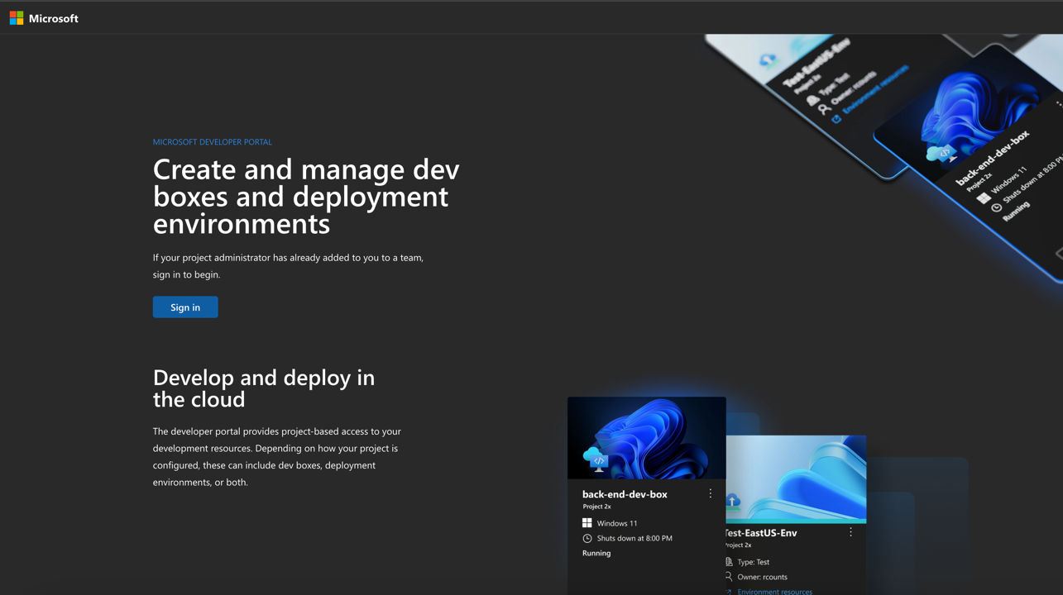

Input the assigned account:

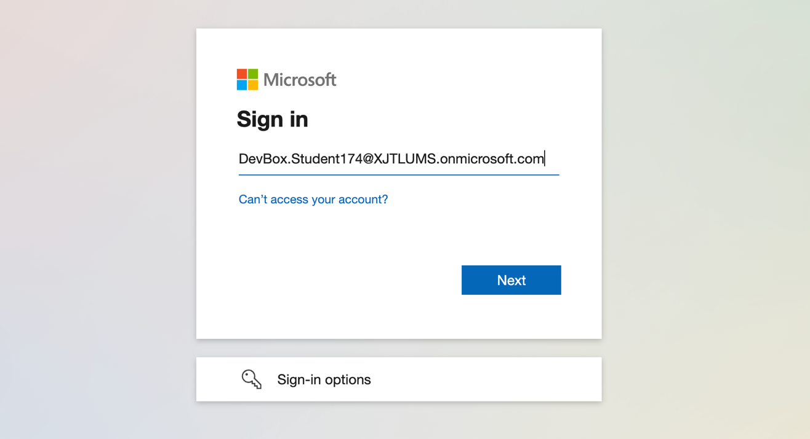

Input the assigned password:

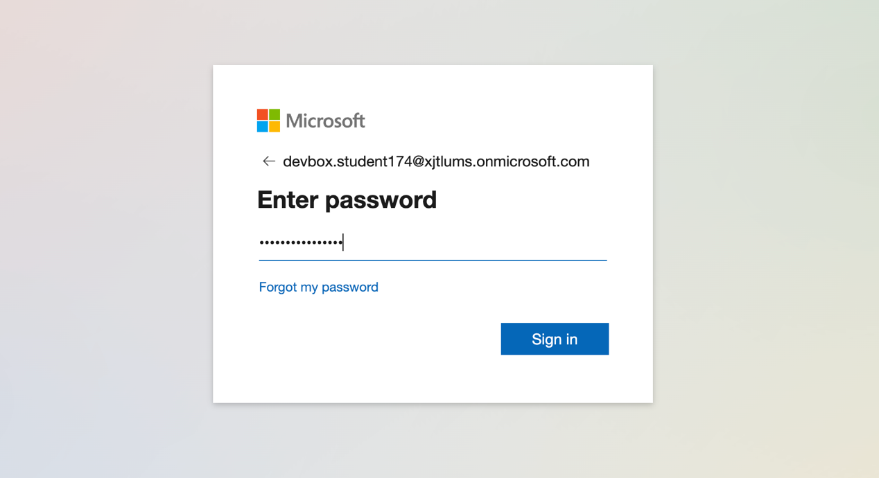

Click yes:

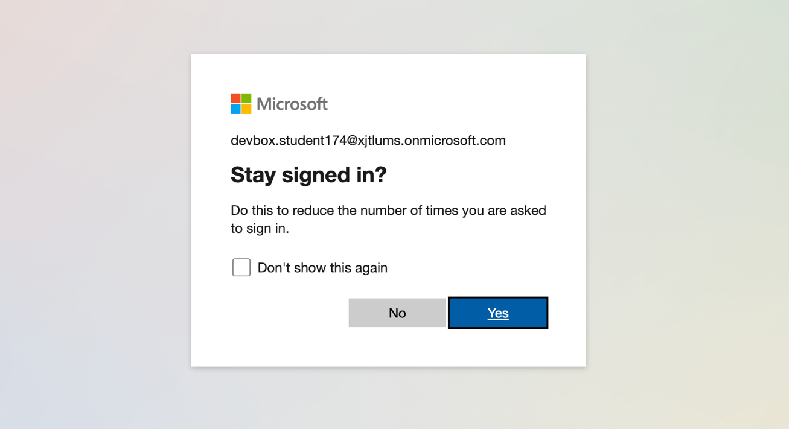

Click continue:

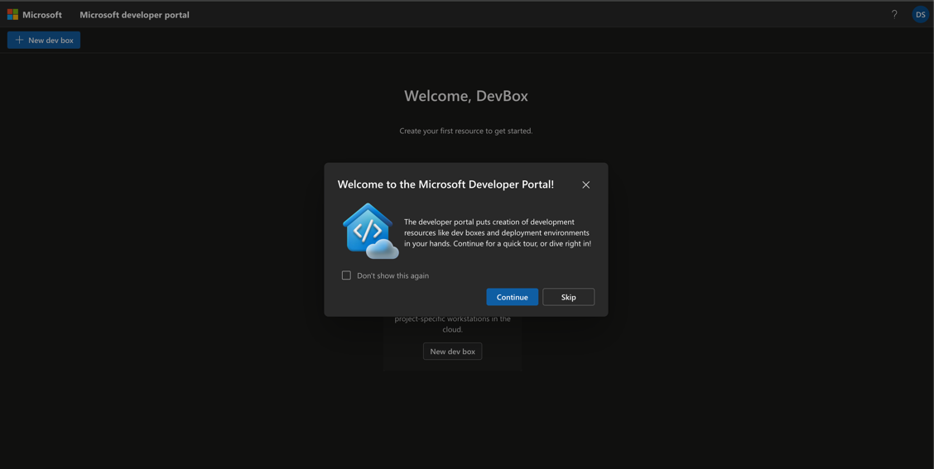

Click new dev box:

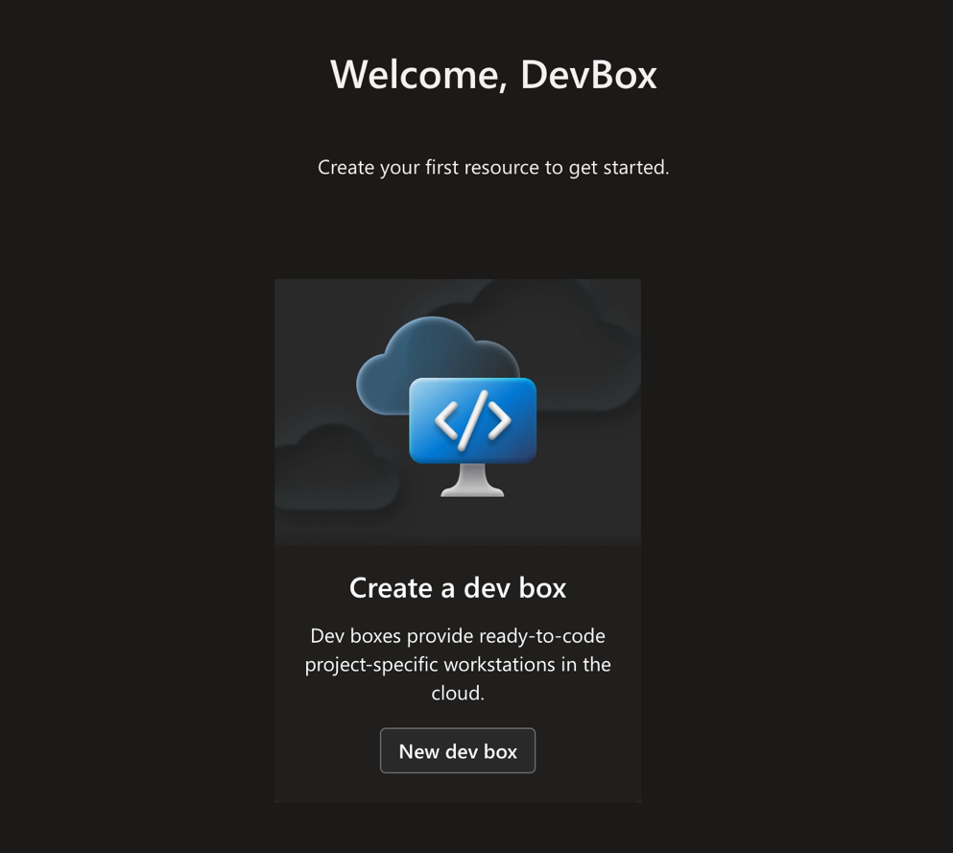

Create a Devbox name (please use your account ID studentxxx):

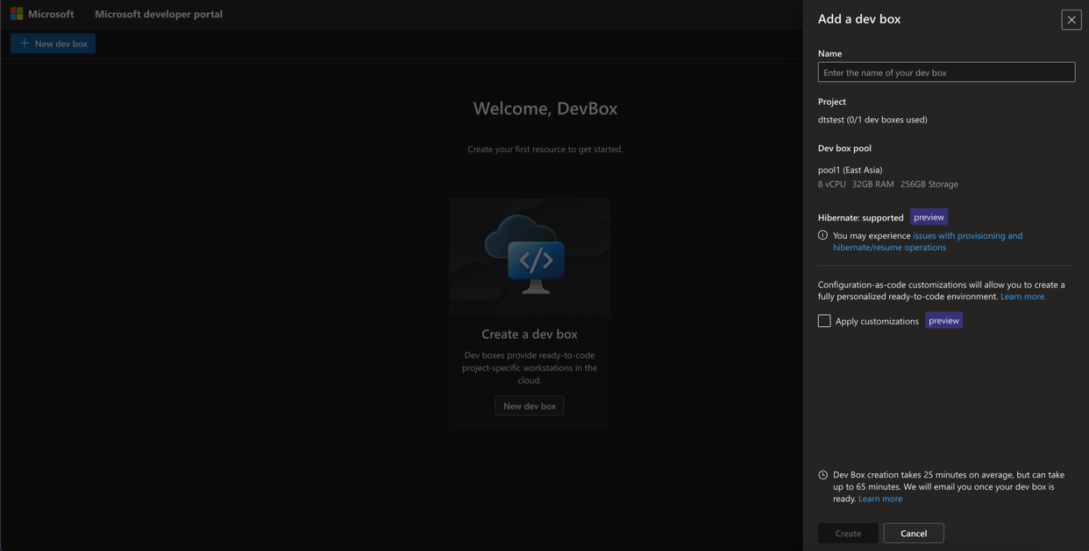

For example, student174 (don’t include space or symbols)

Then click create

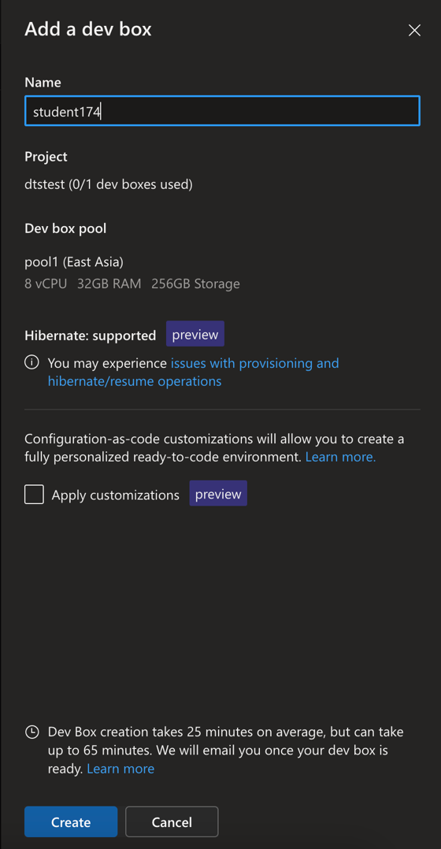

It takes about 1 hour to create the virtual machine at the first time, be patient.

第一次创建需要1个小时，以后再登陆不再需要，请耐心等待。

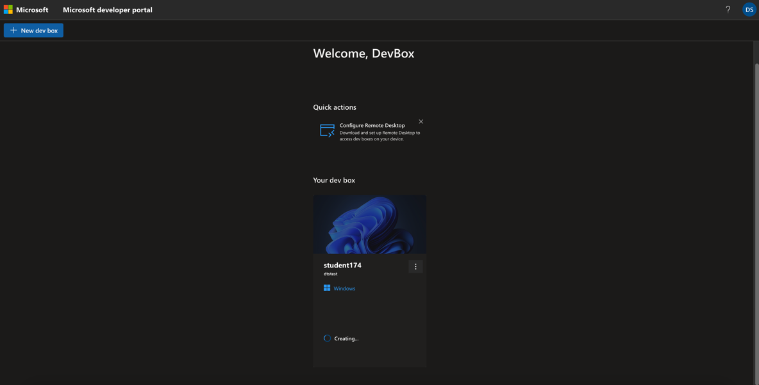

After finish creating, Click open in browser:

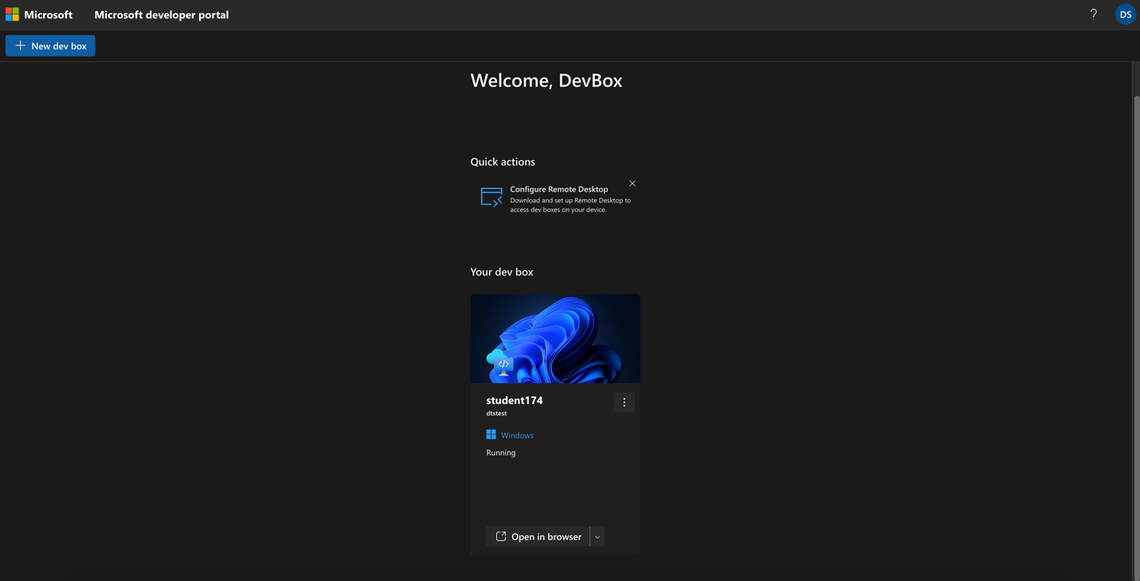

Click connect:

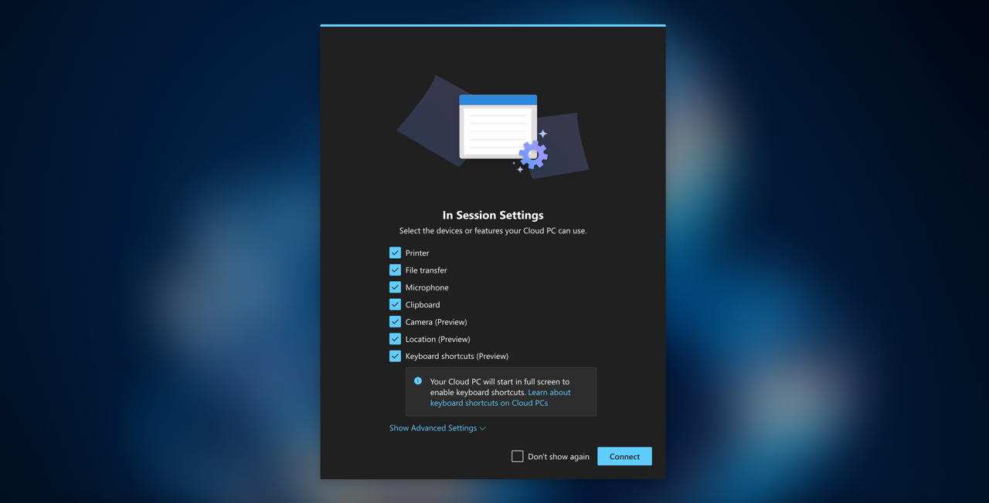

Wait a moment:

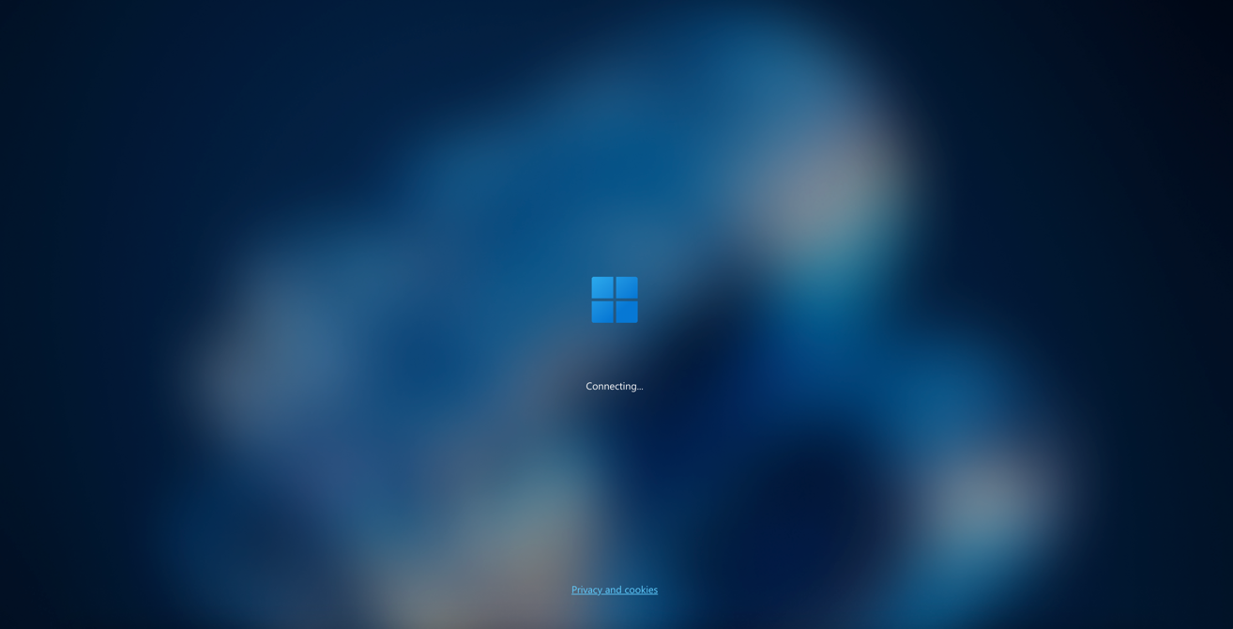

Click sign in

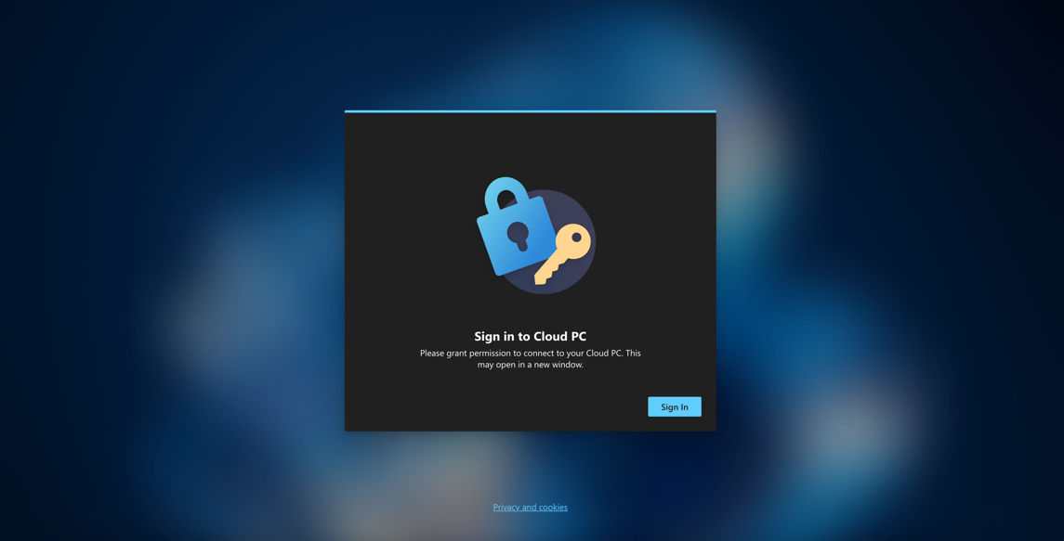

Click yes

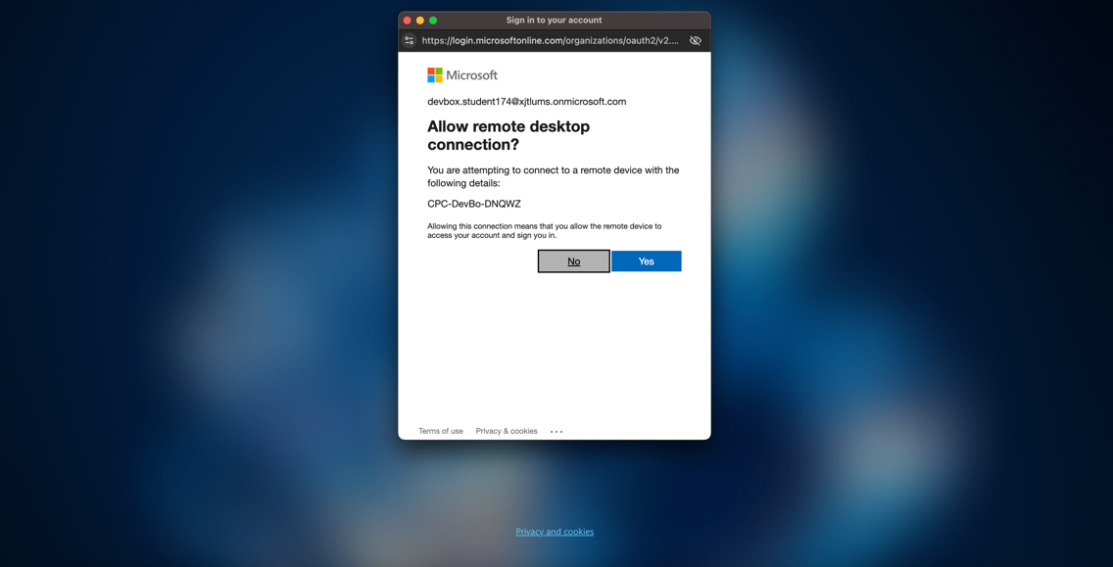

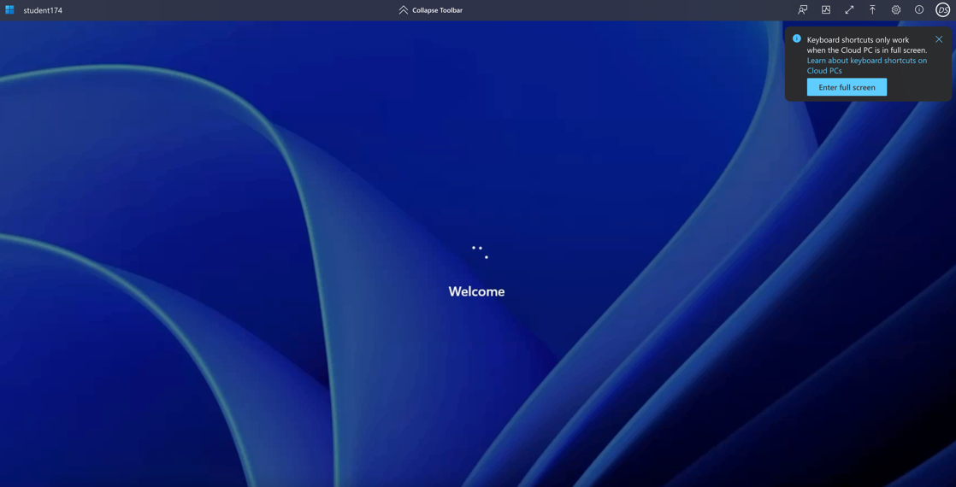

Open anaconda navigator:

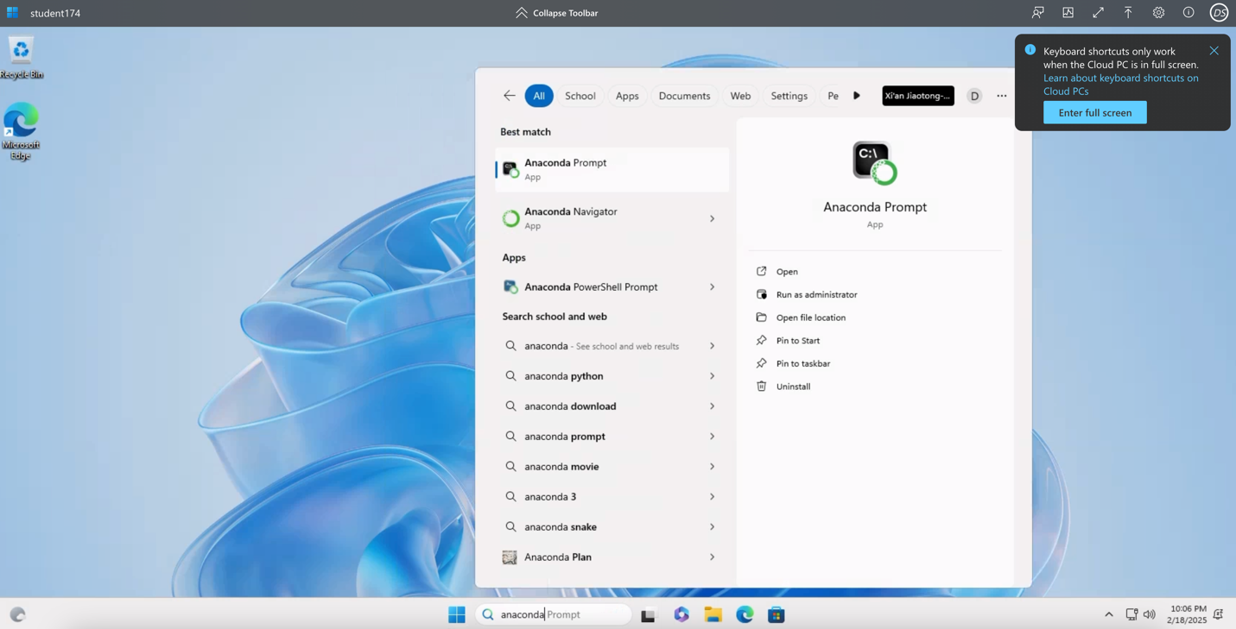

Find Jupyter notebook and launch it

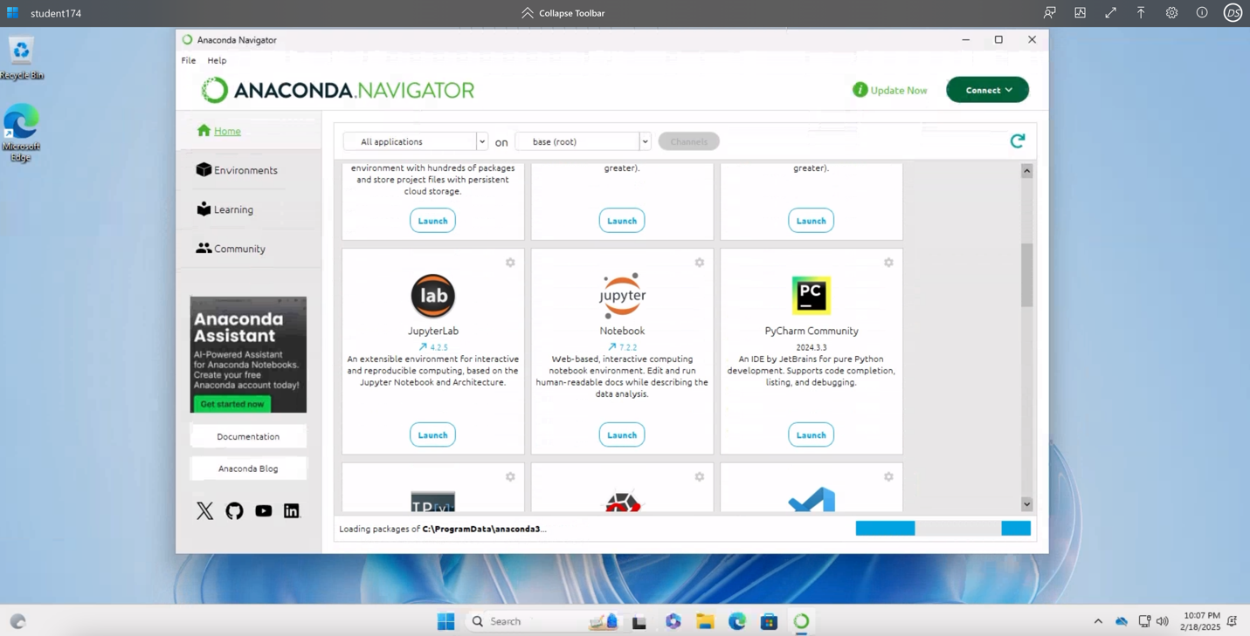

Notebook will open in edge browser:

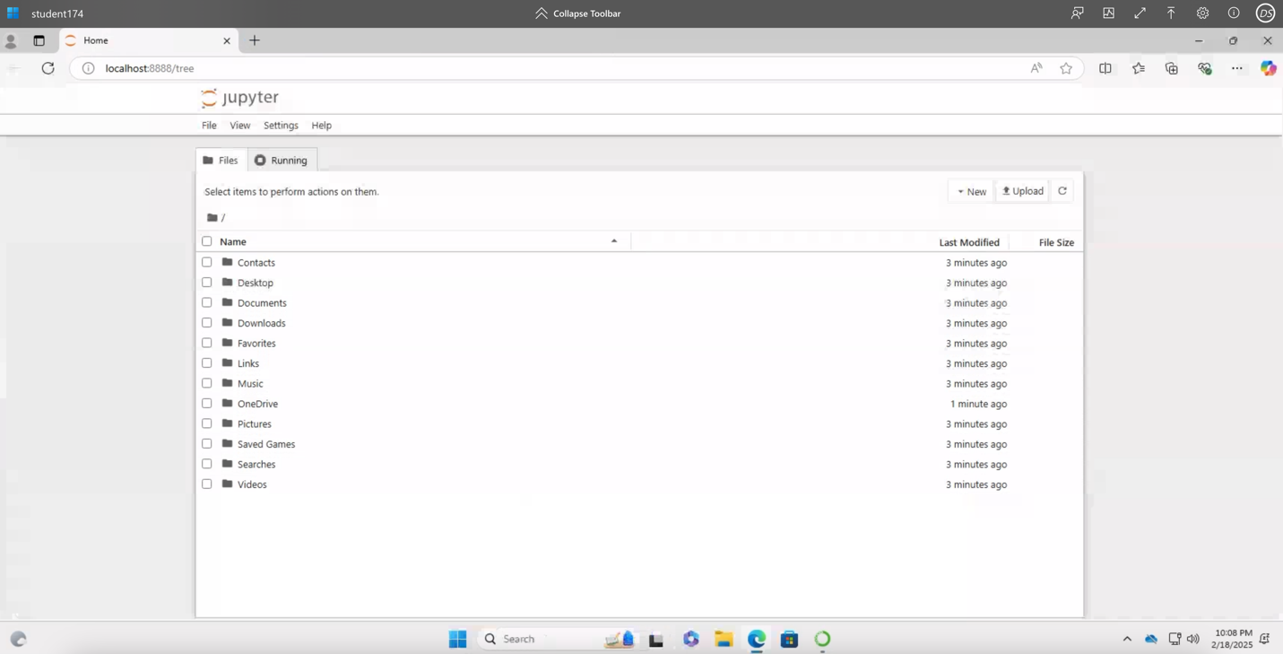

Download files from LMO:

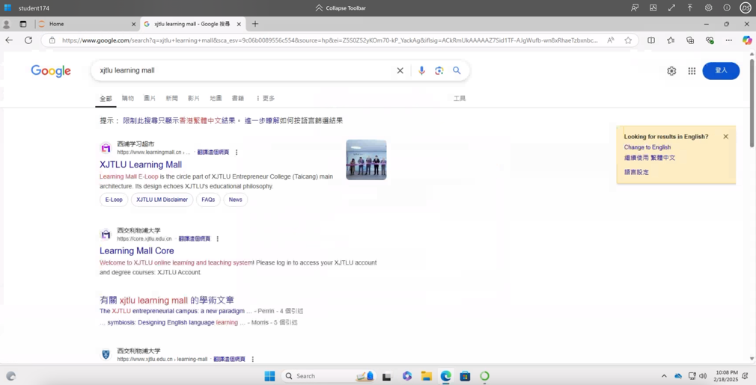

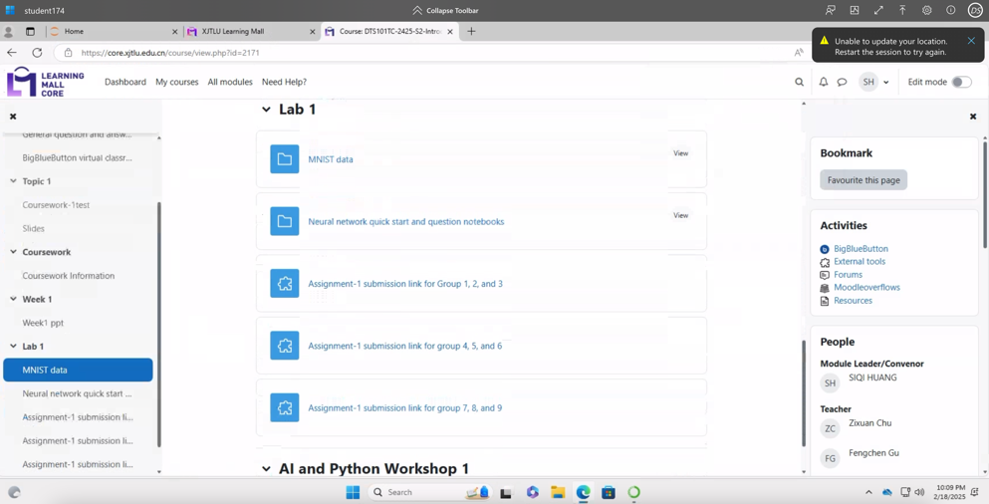

Find the files in the Download folder:

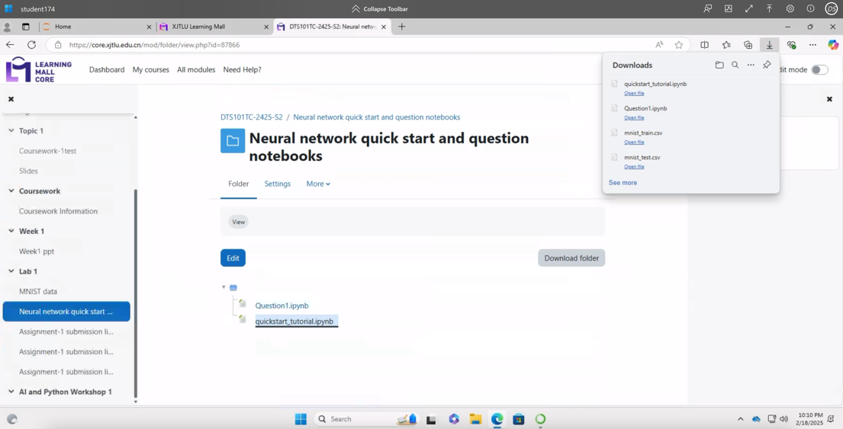

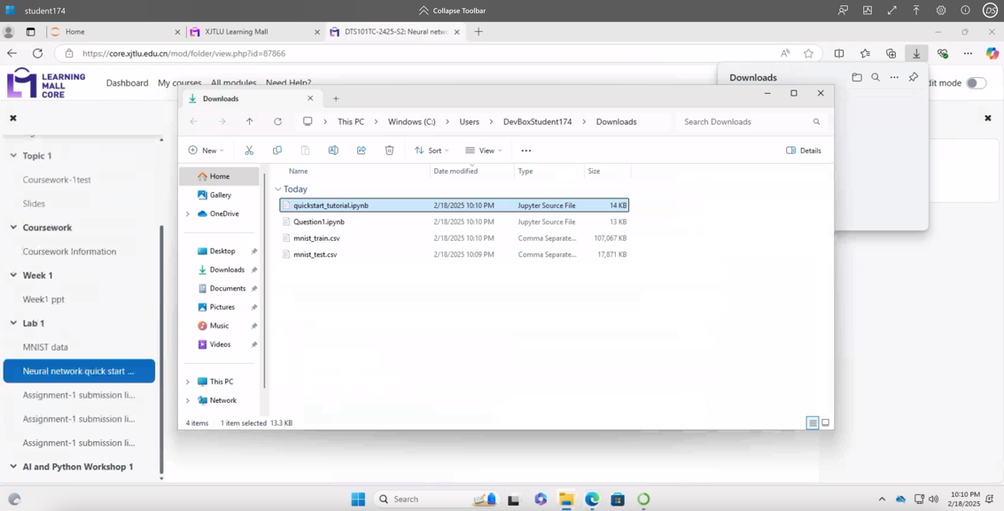

Open the download folder in Jupyter (double click):

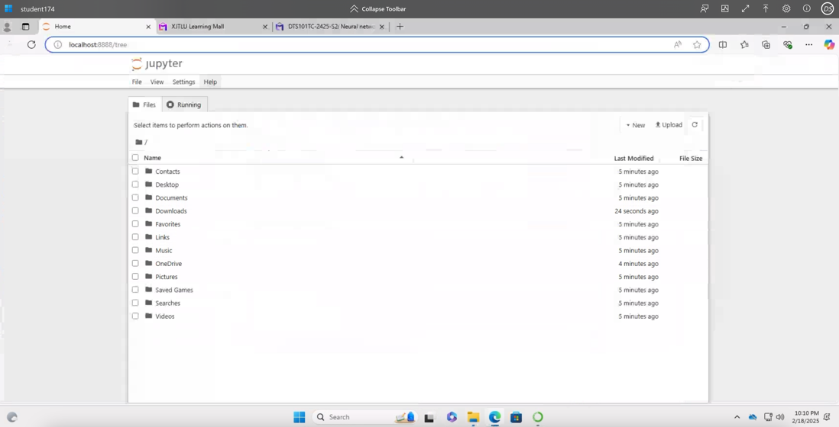

Select and open your notebook file:

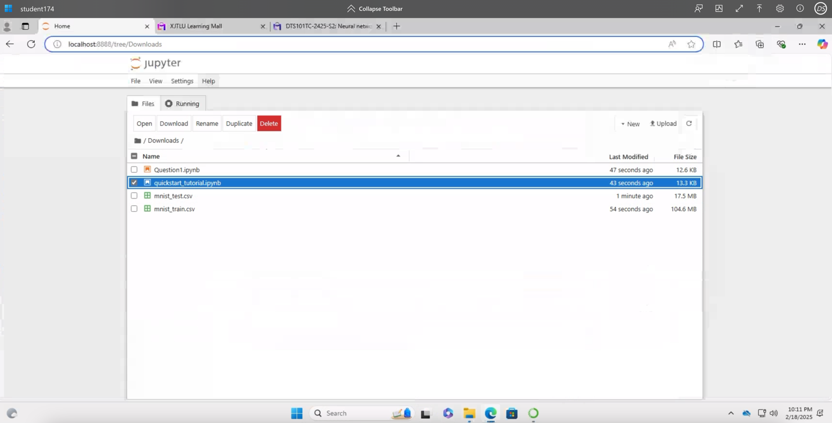

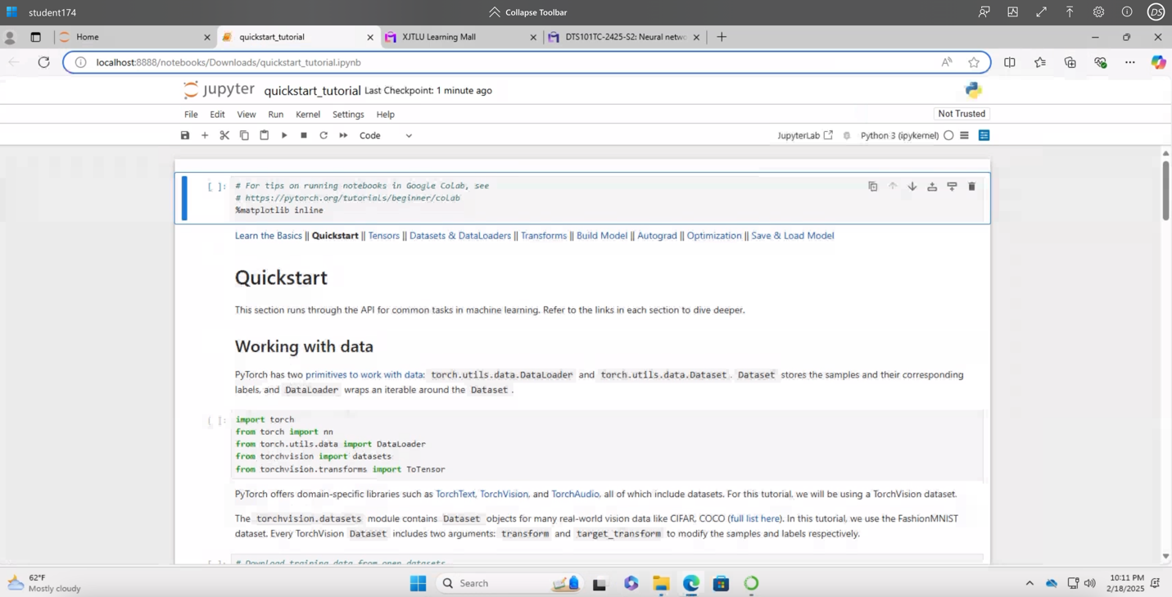

Run all cells:

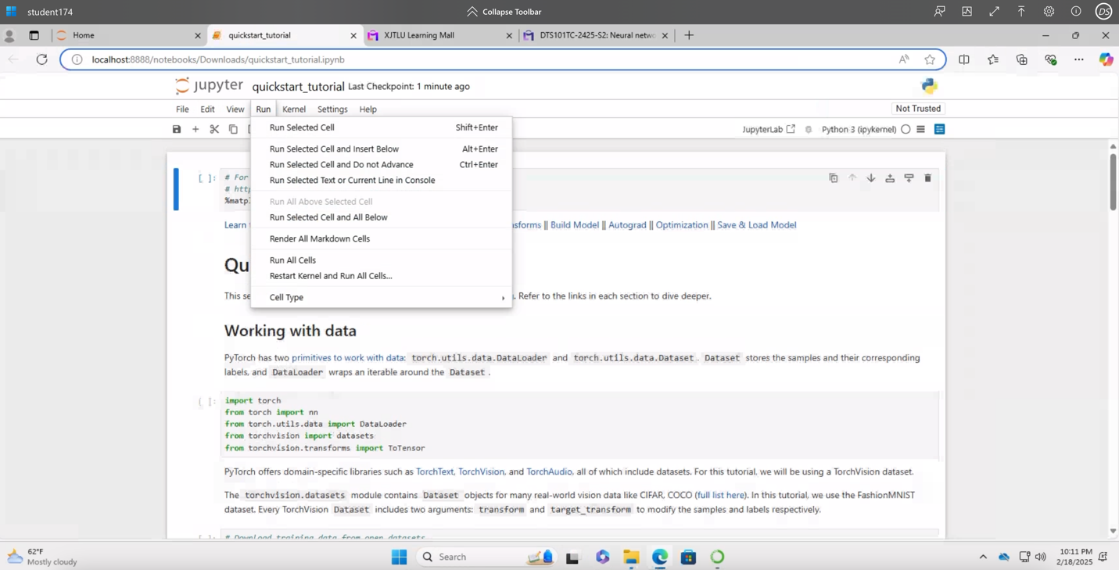

Errors:

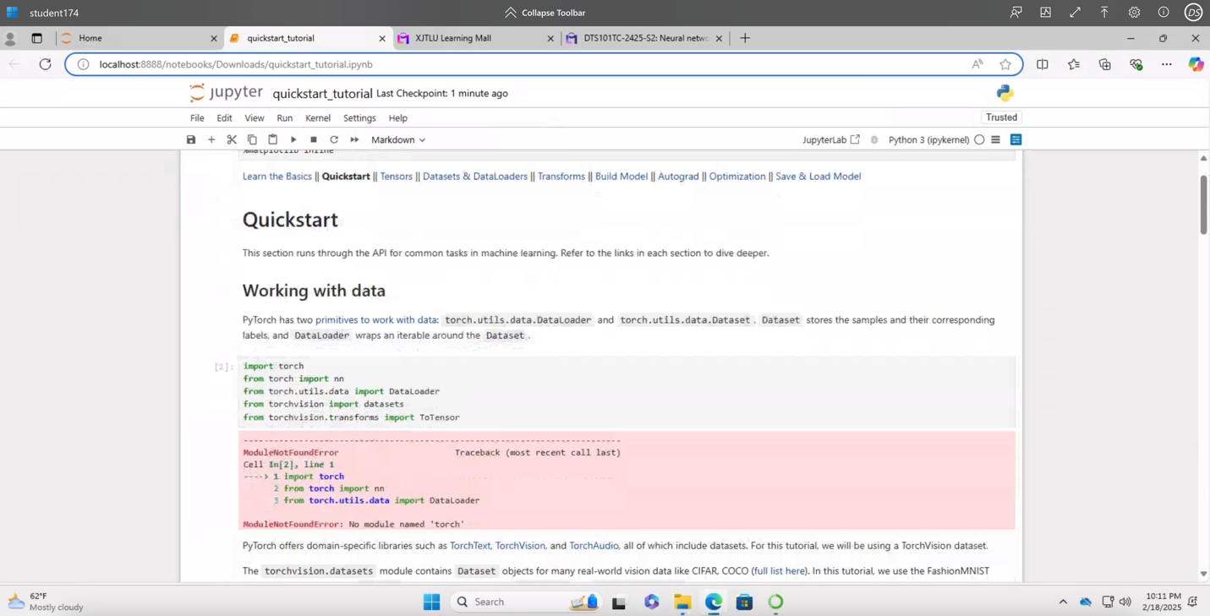

Open anaconda prompt

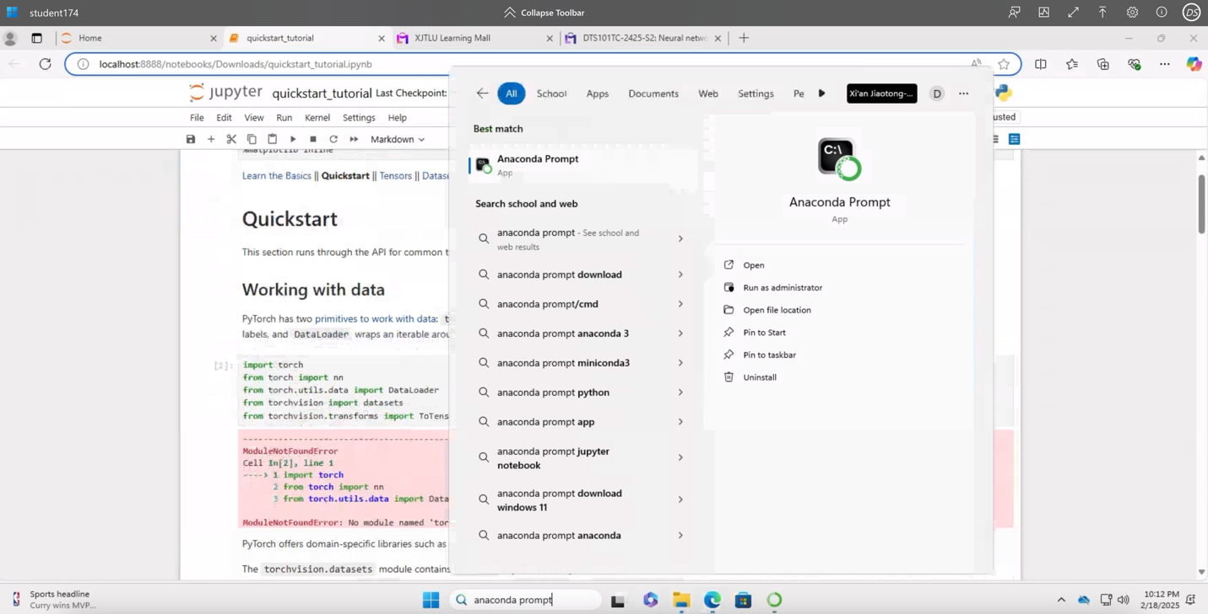

Install torch by typing: pip install torch

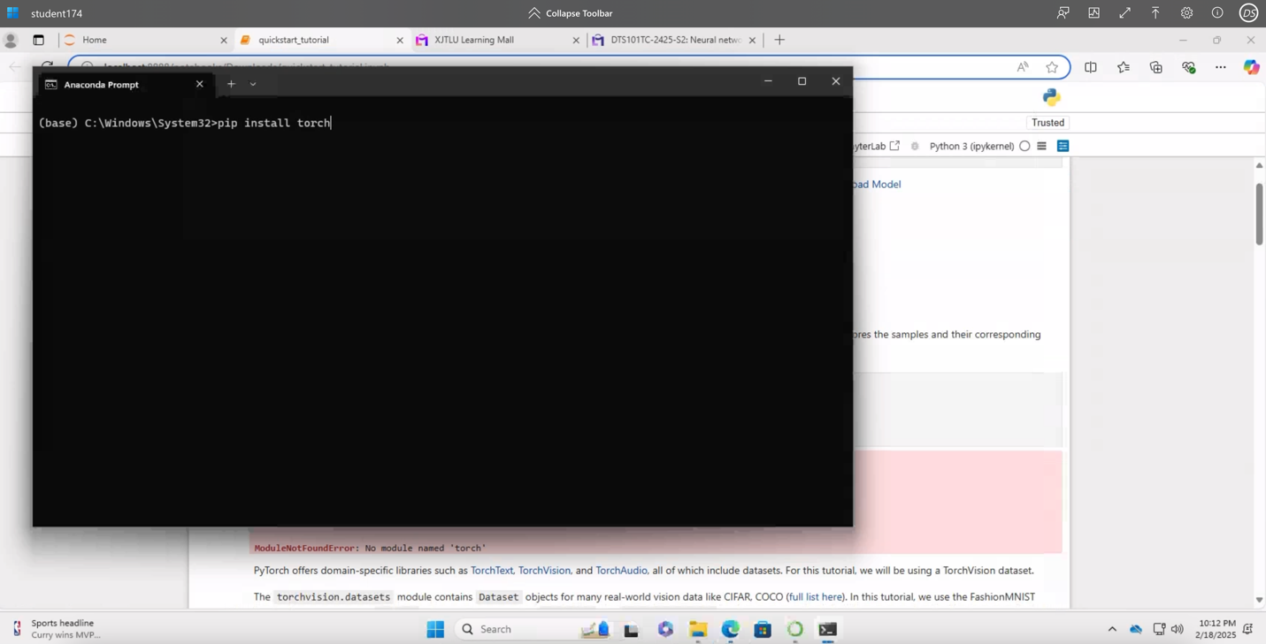

Install torchvision: pip install torchvision

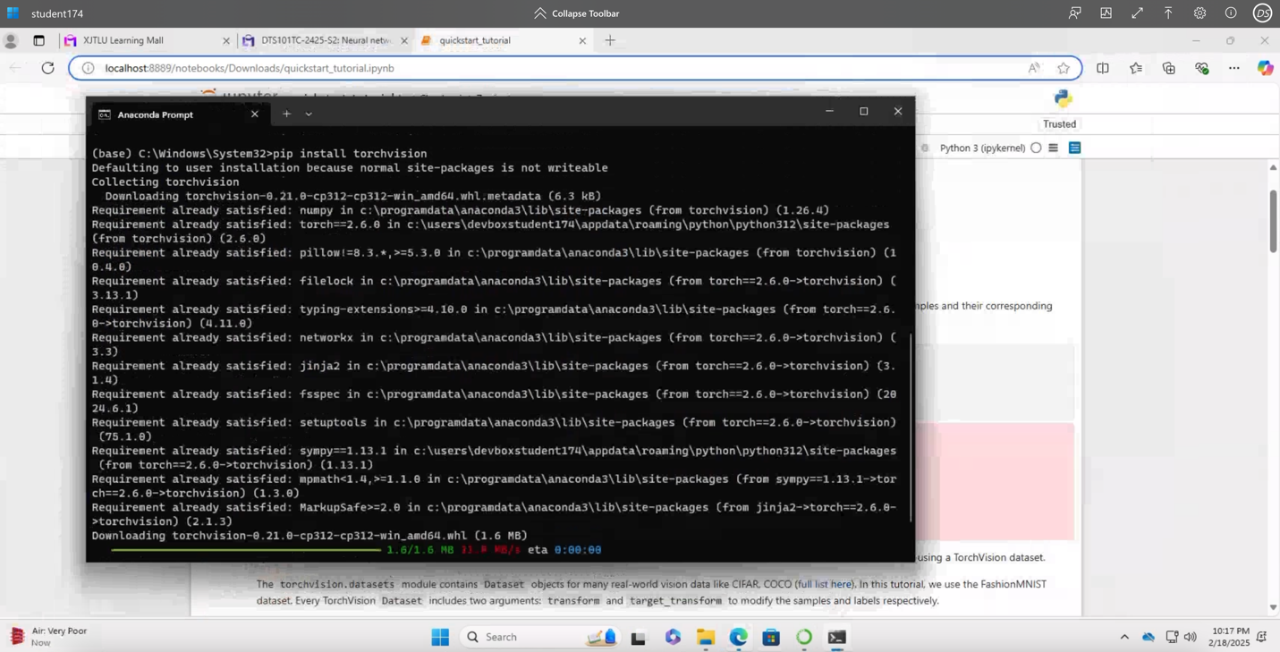

Reopen your notebook and run all cells:

You finished running all code blocks.

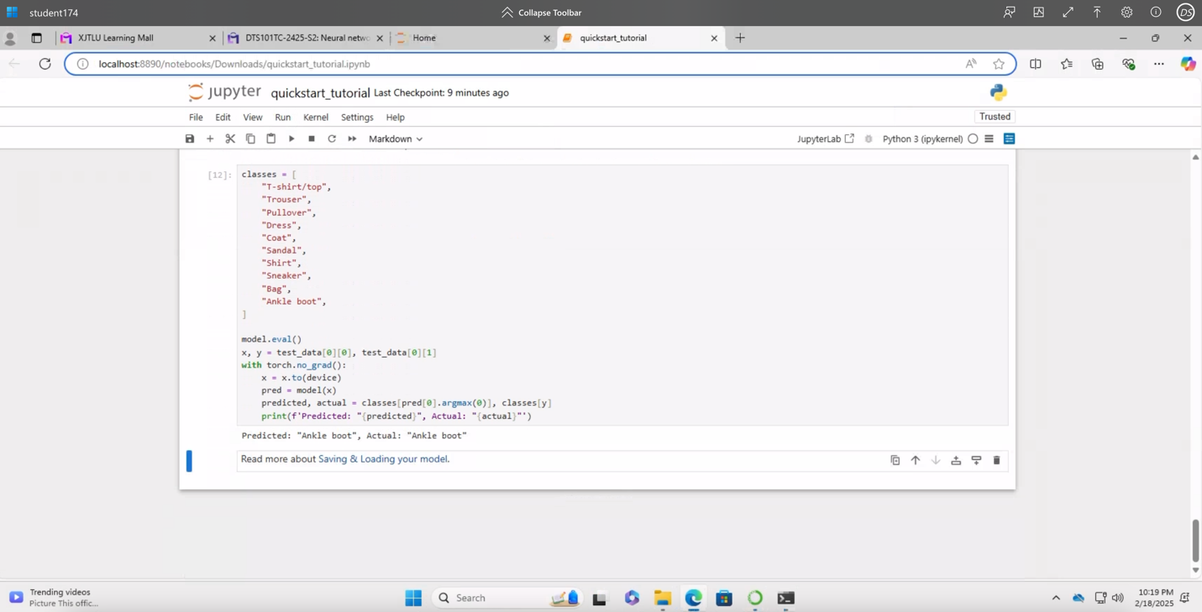

Save and export notebook as HTML:

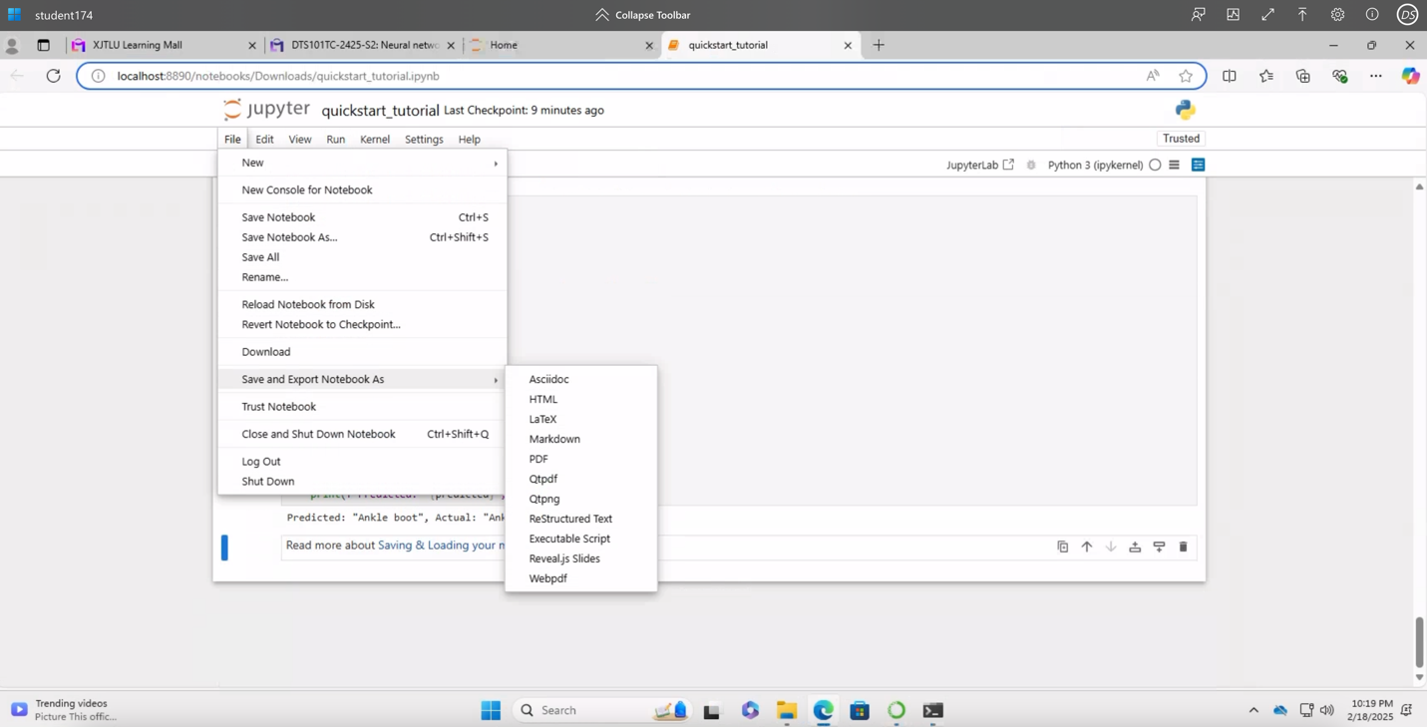

Open the html file:

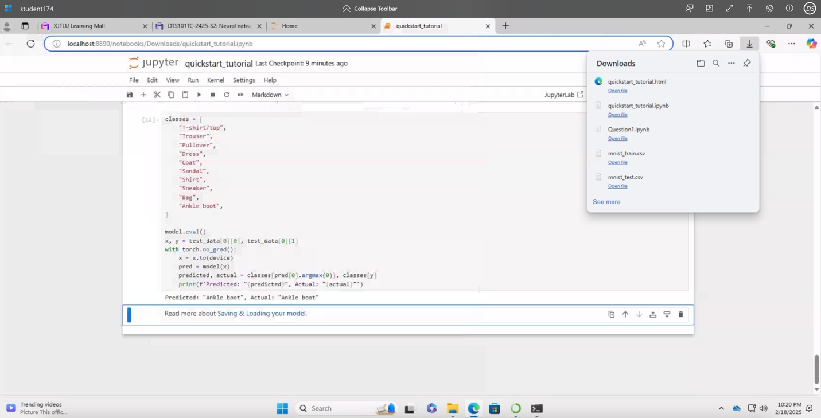

Print as pdf (ctrl + p or open setting and choose print):

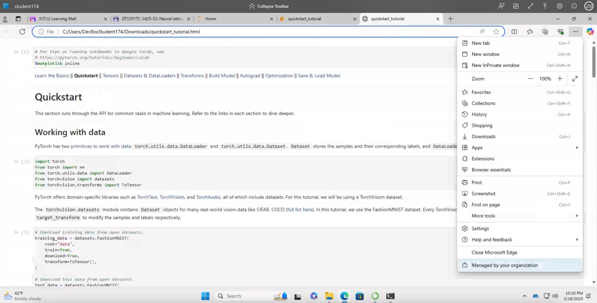

Choose save as PDF:

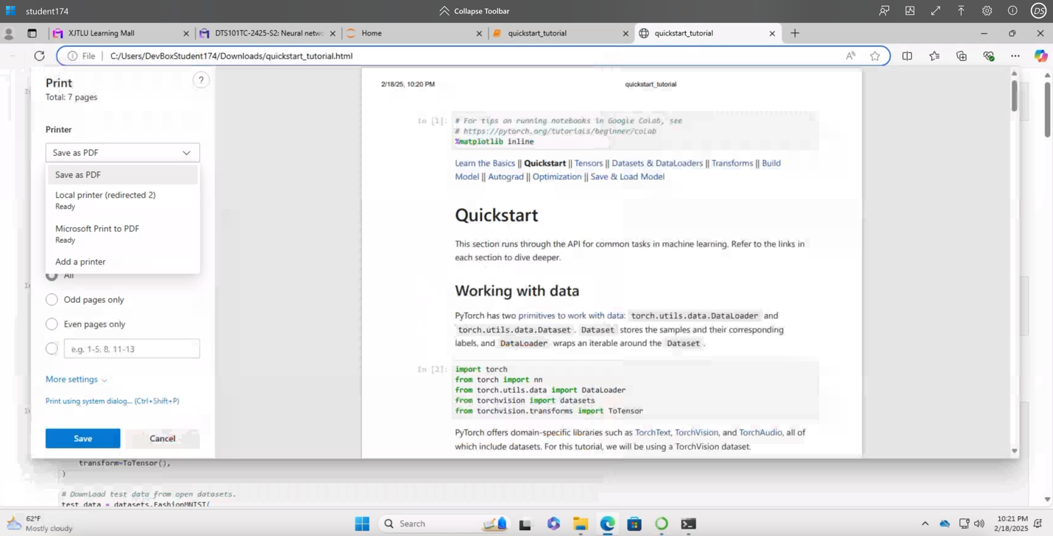

Rename and choose the path of the PDF file:

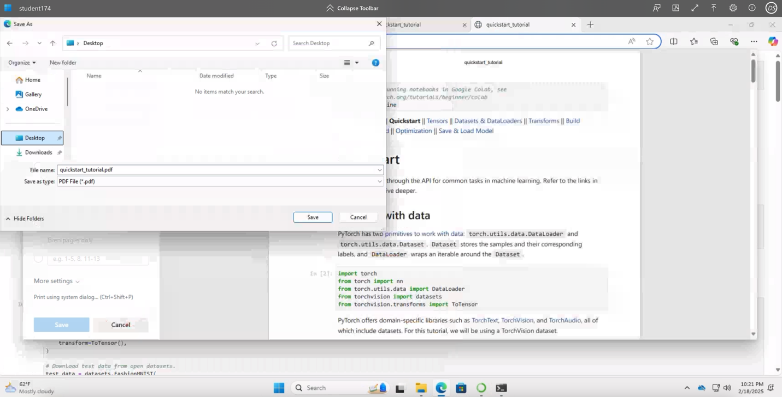

If you choose Desktop, you can find it there:

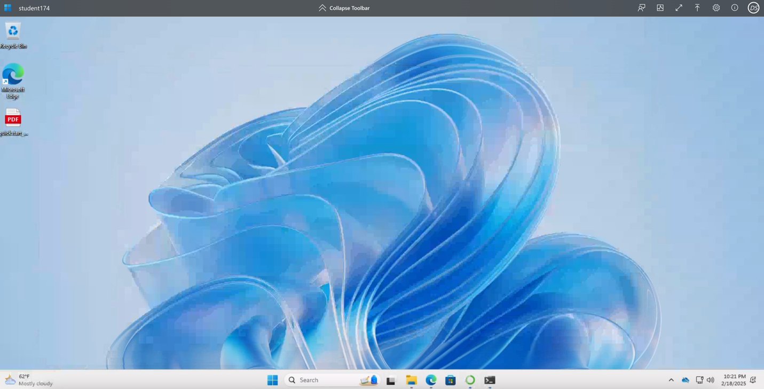

Submit the PDF file using LMO lab assignment submission link

Disconnect the Devbox VM:

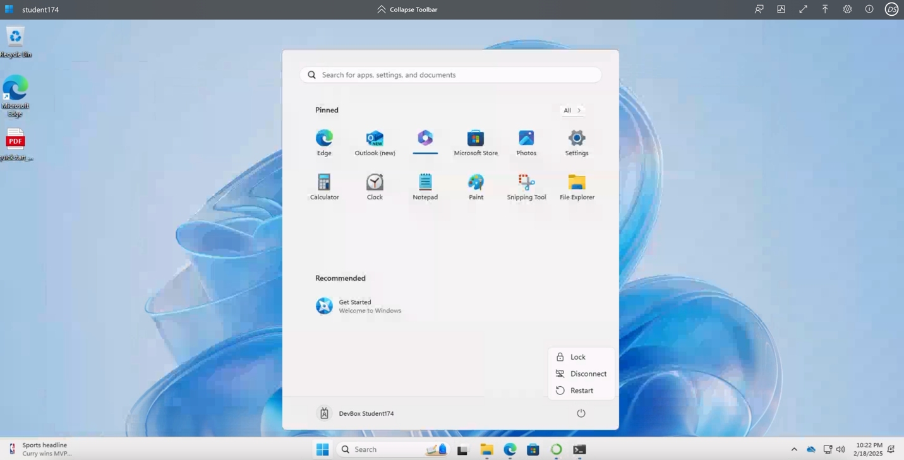

Shut down your Devbox VM:

